# Homework 4 – Rui Qin 30874157 Studio 25 Mon 18:00 Ashwini Narasimha

[RuiQin30874157 Visualization 2 (2xuid.github.io)](https://2xuid.github.io/A2/)

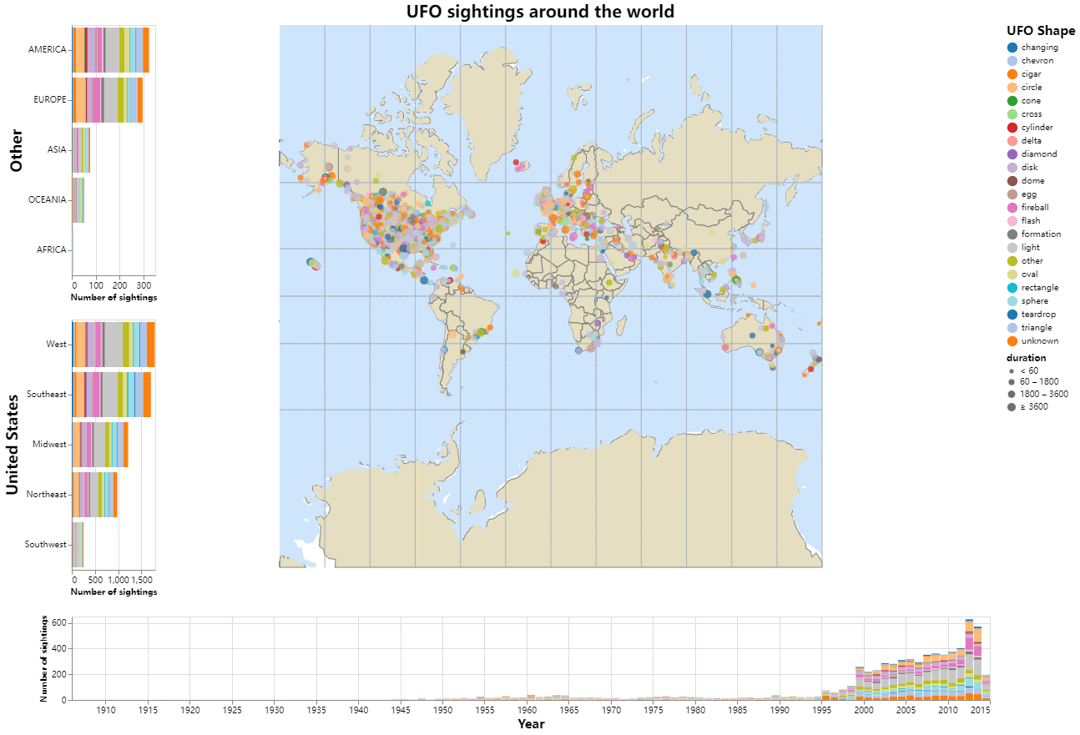

* Domain of the visualisation: UFO sightings around the world
* Visualised dataset:
  + Attribute types: datetime, city, state, country, shape, duration, comments, latitude, longitude, US region
  + Source: National UFO Reporting Center (NUFORC)
  + Author: National UFO Reporting Center (NUFORC)
  + Link: [UFO Sightings | Kaggle](https://www.kaggle.com/datasets/NUFORC/ufo-sightings)
* Data transformation: None
* The stacked bar chart is chosen to effectively display the distribution of UFO sightings by shape across different countries. This visualization allows for easy comparison of sighting frequencies by shape within each country, providing a clear visual representation of the data.